**Justification for SA1 level data rather than SA2-level data**

For the purpose of our study, SA2-level data does not provide the level of granularity required to identify spatial patterns in determinants that affect heat and liveability indicator outcomes. Image 1 below shows the region of Sydney in NSW with SA1 boundaries in red and SA2 boundaries in blue:

Image 1: Map of Sydney SA1 and SA2 boundaries

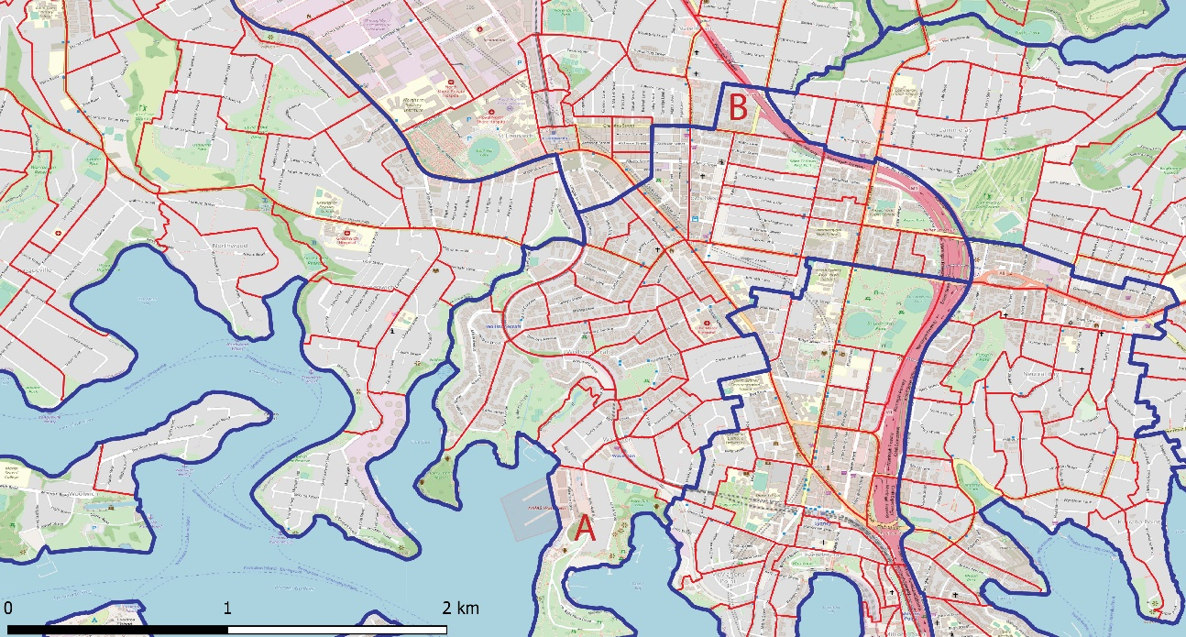

Image 1: Map of Sydney SA1 and SA2 boundaries

(i) As shown in the image, environmental determinants, such as vegetation, access to parks and proximity to water bodies which are known to affect heat vulnerability and liveability are highly variable spatially within the SA2 geography. For example, within the same SA2 there is a discernible difference in the environmental determinants at location (A) near the bay, and location (B) further inland which has a higher built-up density and lower accessibility to green space and water bodies (see Image 1).

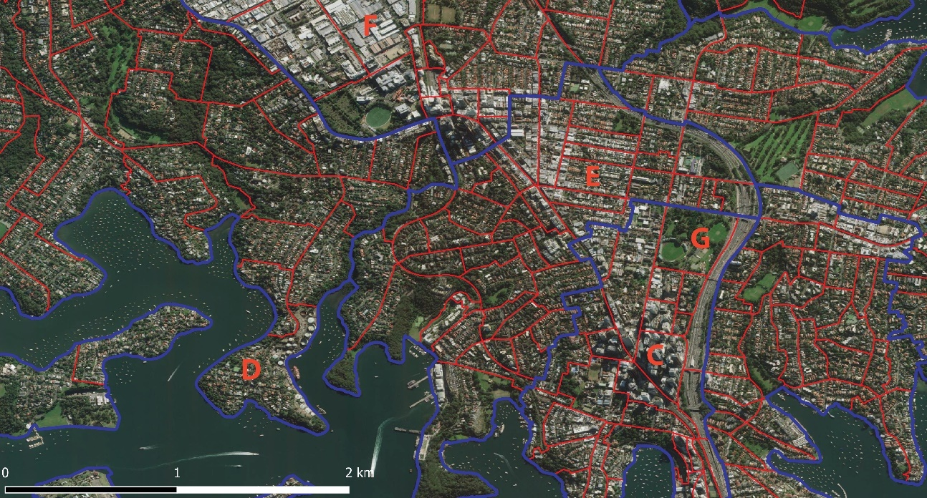

Image 2: Map of Sydney SA1 and SA2 boundaries showing the urban fabric

(ii) In addition, built environment determinants such as urban density, impervious surface and land use can mitigate or amplify the adverse effects of urban heat on population health. Image 2 shows the spatially variable urban fabrics of Sydney. As can be seen from the image, vulnerability profiles will be different for people living in high-rise (C) and low-density low-rise homes (D), as well as for dense residential neighbourhoods (E), parks and recreational areas (G) and industrial areas (F). SA1 level data captures the level of detail required for built environment analysis, which would be lost through aggregation and smoothing at a SA2 level of analysis, producing unreliable indicator outcomes (See Image 2).

(iii) A SA2 geography not only fails to capture the variability and detail of environmental determinants and urban form, it results in significant averaging of the underlying population socioeconomic characteristics that are critical in order to understand drivers of population health outcomes. For example, Figure 3 and Figure 4 show the Index of Relative Socio-Economic Advantage and Disadvantage (SEIFA) for the same areas at SA1 and SA2 geographies.

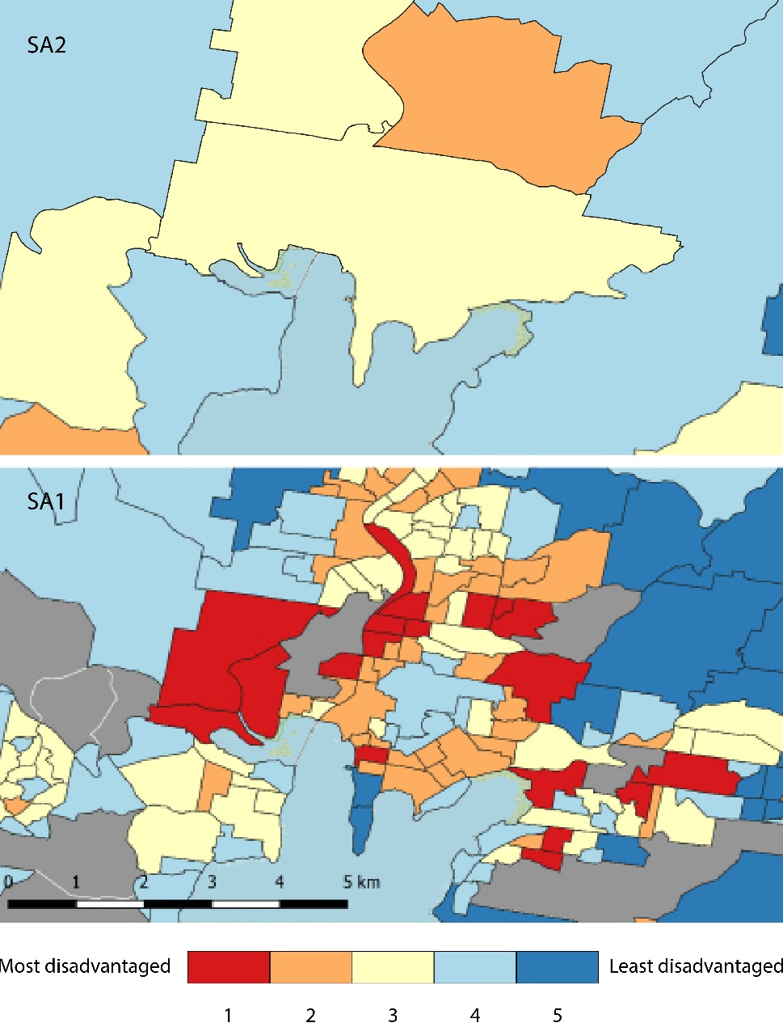

Image 3: Map of Gosford showing SEIFA Index at SA1 and SA2 level

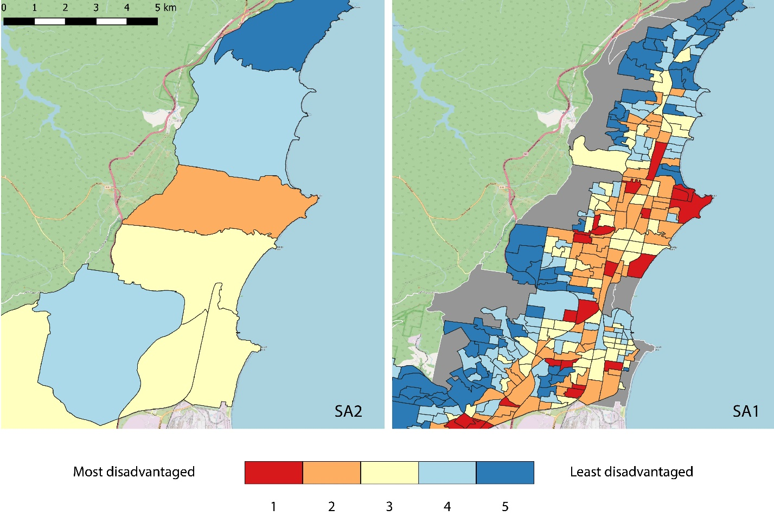

Image 4: Map of Wollongong showing SEIFA Index at SA1 and SA2 level

As can be seen in the figures, SA1 level data captures areas that are most and least disadvantaged. The data is spatially heterogenous and presents higher variability across the same study area compared to SA2 level data. Indicator scores are averaged across large areas at SA2, which would cause statistical errors and misinterpretation as a result of the ecological fallacy and the modifiable area unit problem (MAUP). It is particularly important in public health research because the health status of an individual is influenced by multiple factors that can vary at different spatial scales across geographic regions and existing literature provides evidence that health outcomes are associated with local neighbourhood factors. The coarse granularity of SA2 level data could result in higher variability and significantly different outcomes, thus making the output heat vulnerability indicator less reliable. Therefore, access to SA1 level analysis is required to produce statistically rigorous indicator outcomes that captures health outcomes in relation to socioeconomic characteristics of the study areas.